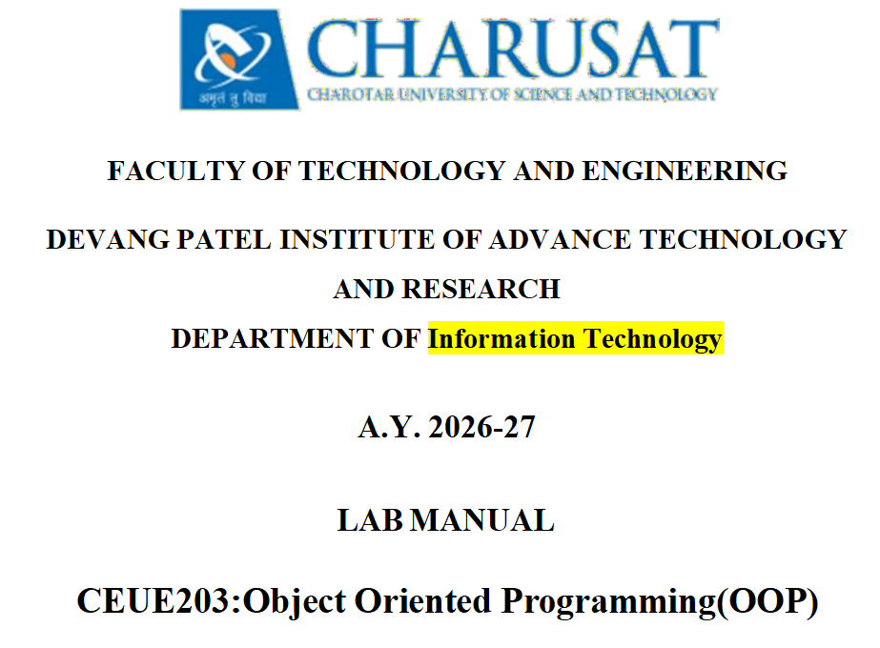
–––––



Practicle 1:-

Part A — Practice Programs

- Vending machine:

Problem Statement:-
(a) Define an enum Coin with constants ONE, TWO, FIVE, TEN.
(b) In main, set a snack price of 15 and a running total of 0; create a Scanner.
(c) Loop: read a coin name, use a switch expression to convert the Coin to its value
(ONE→1, TWO→2, FIVE→5, TEN→10), add it to the total, and print the total so
far.
(d) Stop the loop once the total reaches 15 or more.
(e) Print the change to return (total − 15).
Solution:-

import java.util.Scanner;
enum Coin{
ONE,
TWO,
FIVE,
TEN
};
public class VendingMachine {
public static void main(String[] args) {
int snackprice = 15;
int total = 0;
Scanner sc = new Scanner(System.in);

while(total < snackprice){
System.out.println("Please insert a coin (1, 2, 5, 10): ");
String input = sc.next().toUpperCase();
Coin coin = Coin.valueOf(input);
int coinval = switch(coin){
case ONE -> 1;
case TWO -> 2;
case FIVE -> 5;
case TEN -> 10;
};
total += coinval;
if(total < snackprice){
System.out.println("Total so far: " + total);
}
}
int change = total - snackprice;
System.out.println("Total so far: " + total);
System.out.println("Change returned: " + change);
sc.close();
}
}

Output:-

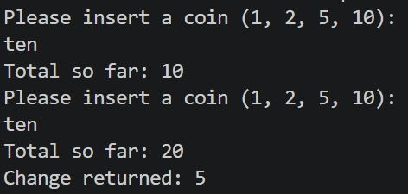

- Toll booth:

Problem Statement:-
(a) Define a record Vehicle(String number, String type).
(b) In main, keep a running toll total and three counters (bike, car, truck).
(c) Loop until the user types “done” for the number: build a Vehicle, use a switch
expression on its type for the toll (bike→20, car→50, truck→150), add to the total,
and increment that type’s counter.
(d) After the loop, print the total toll and the type with the highest count.

Solution:-

import java.util.Scanner;
public class TollPlaza {
record Vehicle(String number, String type) {}
public static void main(String[] args) {
Scanner sc = new Scanner(System.in);
int totalToll = 0;
int bikeCount = 0;
int carCount = 0;
int truckCount = 0;
while (true) {
System.out.print("Enter Vehicle Number (or 'done' to stop): ");
String number = sc.nextLine();
if (number.equalsIgnoreCase("done")) {
break;
}
System.out.print("Enter Vehicle Type (bike/car/truck): ");
String type = sc.nextLine().toLowerCase();
Vehicle v = new Vehicle(number, type);
int toll = switch (v.type()) {
case "bike" -> {
bikeCount++;
yield 20;
}
case "car" -> {
carCount++;
yield 50;
}
case "truck" -> {
truckCount++;
yield 150;
}
default -> {
System.out.println("Invalid vehicle type! Toll = 0");
yield 0;
}
};
totalToll += toll;
}
String highestType;
if (bikeCount >= carCount && bikeCount >= truckCount) {
highestType = "Bike";
} else if (carCount >= bikeCount && carCount >= truckCount) {
highestType = "Car";
} else {
highestType = "Truck";
}
System.out.println("Toll Summary");
System.out.println("Total Toll Collected : " + totalToll);
System.out.println("Bike Count : " + bikeCount);
System.out.println("Car Count : " + carCount);
System.out.println("Truck Count : " + truckCount);
System.out.println("Highest Count Type : " + highestType);
sc.close();
}
}

Output:-

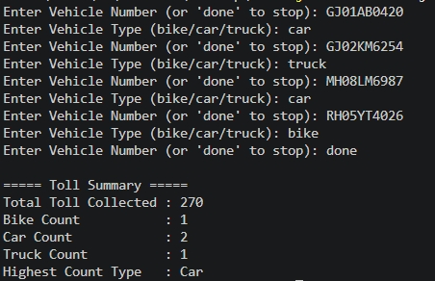

Part B — Project Work : MiniBank

Problem Statement:-
MiniBank is the console banking application you will build across the whole semester. In
this first lab you set up your tools and create the project and its menu shell — the screen the
user navigates. Every later lab attaches one real banking feature behind these menu options.
1. Set up your environment: open the project in GitHub Codespaces (or install JDK 17+ and
an IDE locally), and create a private GitHub repository named oop-minibank-<rollno>;
add the faculty as a collaborator.
2. Create a public class named MiniBank that contains the main method.
3. Define a record named BankInfo with two String fields, name and branch (a record is a
short, read-only class; Java auto-generates its constructor and field accessors). Print one
BankInfo object as the application header.
4. Define an enum named MenuOption with the constants OPEN_ACCOUNT, DEPOSIT,
WITHDRAW, TRANSFER and EXIT — these are the actions MiniBank will offer.
5. Display the numbered menu to the user and read the chosen number with a Scanner.
6. Use a switch expression on the choice to print a short placeholder for that option (for
example, “Deposit — to be implemented in a later lab”). Keep showing the menu in a
loop until the user selects EXIT, then print a goodbye message.

Solution:-

import java.util.Scanner;
record BankInfo(String name, String branch) {
enum MenuOption {
OPEN_ACCOUNT,
DEPOSIT,
WITHDRAW,
TRANSFER,
EXIT
}
public class minibank_1 {
public static void main(String[] args) {
Scanner sc = new Scanner(System.in);
BankInfo bank = new BankInfo("MiniBank", "Anand Branch");
System.out.println(" MINI BANK APPLICATION");
System.out.println(bank);
System.out.println();
boolean running = true;
while (running) {

System.out.println("MAIN MENU ");
System.out.println("1. Open Account");
System.out.println("2. Deposit");
System.out.println("3. Withdraw");
System.out.println("4. Transfer");
System.out.println("5. Exit");
System.out.print("Enter your choice: ");
int choice = sc.nextInt();
String message = switch (choice) {
case 1 -> MenuOption.OPEN_ACCOUNT + " - To be implemented in a later lab.";
case 2 -> MenuOption.DEPOSIT + " - To be implemented in a later lab.";
case 3 -> MenuOption.WITHDRAW + " - To be implemented in a later lab.";
case 4 -> MenuOption.TRANSFER + " - To be implemented in a later lab.";
case 5 -> {
running = false;
yield "Thank you for using MiniBank!";
}
default -> "Invalid choice! Please try again.";
};

System.out.println(message);
}
System.out.println("Goodbye!");
sc.close();
}
}
Output :-



